Project Design Phase
Solution Architecture
Date | 19 Feb 2026
Team ID | LTVIP2026TMIDS39481
Project Name | ShopSmart: Your Digital Grocery Store Experience
Solution Architecture:

The solution architecture of ShopSmart is structured to address the business need for a seamless, scalable, and efficient online grocery shopping experience. The architecture effectively connects user-facing interfaces with backend services and data storage systems to ensure responsive and secure operations for customers, sellers, and administrators.
Key Goals of the Architecture:
- Identify the best-fit technology stack (MERN) to address the core challenges of traditional grocery shopping.
- Design a robust system capable of handling dynamic user roles and real-time operations.
- Define component interaction, data flow, and modular responsibilities across the system.
- Ensure maintainability, scalability, and performance optimization in a live e-commerce environment.
Architecture Layers and Components:
- Frontend Layer (React.js):
  - Provides dynamic and interactive UI for different user roles (Customer, Seller, Admin).
  - Implements responsive design using modern libraries to support both mobile and desktop.
  - Integrates features like product listings, search filters, shopping cart, login/register, and order history.
- Backend Layer (Node.js + Express.js):
  - Acts as the central API layer handling all HTTP requests from the frontend.
  - Uses Express routes and controllers to manage business logic like authentication, cart updates, product CRUD operations, and order processing.
  - Implements JWT-based authentication and middleware for secure and role-specific access control.
- Database Layer (MongoDB):
  - Stores structured collections for Users, Products, Orders, Admins, and Carts.
  - Supports flexible document-based storage, enabling quick updates and retrievals for dynamic shopping behavior.
  - Integrated using Mongoose ODM to simplify queries and enforce data validation rules.
- Authentication & Authorization:
  - JWT tokens are issued on login and stored in frontend localStorage.
  - Tokens are validated on every API call to ensure secure access.
  - Access is controlled through roles: Customers access user features, Sellers manage inventory, and Admins oversee the entire system.
- Real-Time Operations:
  - Cart state, product availability, and admin dashboards reflect live updates.
  - Orders are tracked post-placement, with confirmation sent via email/SMS.
- Deployment and Scalability:
  - Designed for local development (localhost:3000/frontend, 5000/backend) and scalable cloud deployment.
  - Modular folder structure and reusable components allow for easy feature expansion and scaling to additional regions or product categories.
- Error Handling and Security:
  - API endpoints are protected with authentication middleware.
  - Server errors are caught and handled gracefully, with appropriate status codes and user feedback.
  - Passwords are hashed using bcrypt for secure storage.

Technical Architecture:

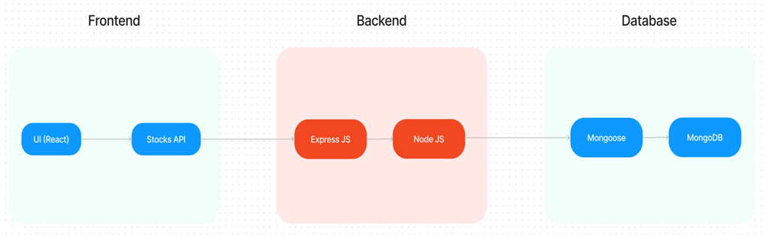
Solution Architecture:
